Q-1 What do you understand by SWOT. Using SWOT analysis describe the Strength , Weakness , Opportunities and threat of company which you know closely. Please use the diagram as well as references.
In order to analyses the standing of a company the issue that ar respectable ar strengths, weakness, opportunities and threats. every issue is studied deeply to know and justify every purpose
In this case we are going to selected one among company in Asian country "Giant". it's one among the most important hypermarkets stores in Asia and specific in Asian country.
Strengths
Giant have their own house merchandise that ar offered low cost costs as compared to alternative competitors. big have on-line web site platform wherever promotions and alternative merchandise ar offered to urge attention of consumers towards the merchandise. Some shoppers ar physically buying totally different enticing promotions in food market.
Weaknesses
They are encountering a high ratio with their representative notably within the operation department, a big range of their employee leaves when simply meeting expectations one or 2 months in their store, that is unhealthy for organization as they'll ought to discover and utilize new staff. to own a productive team is one among the foremost vital issue of a company to resolve out this issue a brand new strategy is planned to stay staff, department and groups which can create it tougher to plans to be dead.
Opportunities
Firstly, they need ready purchasers base demonstrating that consumer base with AN advantageous methodology for searching might create things extraordinary on the grounds that with distended comfort comes unbelievable opportunities. in particular else, distended consumer base. With a lot of purchasers around, we are able to enjoyably grantee-expanded deals consequently serving to big to create their financial gain, Market share, etc. additionally, the delivery platform makes it easy for large to focus on purchasers in areas/ranges wherever big isn't effortlessly accessible.
Threats
Finally, there's a spare competition in terms of E-business. Retail Textile e-business is, little doubt headed by Zalora whereas gadgets is, little doubt headed by Lelong. within the event that enormous enters the E-business market, it might be {the on-line|the web|the net} one giving buying food online which suggests that dissimilar to Zalora and Leonga, they'll ought to execute same day delivery. Material, gadgets, and alternative comparable things will stay for 2-3 days delivery period; but same day delivery with abrupt temperature change and movement gets to be extraordinarily difficult that big can ought to singularly confront.

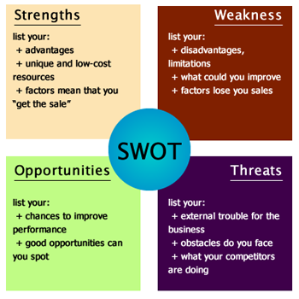
Q-2 Discuss most important factors for successful E-Commerce site designing.
“1. Platform and Theme
Choosing an appropriate platform is the first and foremost step you need to do to build a sales-driven e-commerce site. There are various platforms to choose from: WordPress, Magento, Shopify, Joomla, Drupal, Zen Cart, OpenCart, Prestashop, osCommerce, etc.

2. E-commerce Plugins
E-commerce plugins are essential for any online store. In general, they help with adding a shopping store to your site, installing payment gateways, and keeping track of sales performance.

3. Search Engine Optimization (SEO)
Sales are definitely the vital purpose for running an e-commerce website. If you want to increase your sales and outpoint your competitors, SEO is a must. Search Engine Optimization helps your site to show up when someone searches for your merchandise, and therefore increases your visibility and the possibility of conversion. The higher your rank on the search results page, the more potential customers are reached

4. Website Content
Make sure that your information is precise, up-to-date and helpful. Your clients need a clear, detailed and easy-to-understand text, so try not using long sentences or academic terms in product descriptions, support sections or any other part of the site. “A picture is worth a thousand words”. Instead of a whole bunch of text, utilizing images will make the site more appealing and lively.

5. Check-out Process
Firstly, pay attention to budget allocation. Make sure that you have listed down all the predictable expenses; for instance: hosting fees, license fees, and acquisition costs through advertising (Facebook Ads, Google Ads, etc). Then, define the ultimate price for each item. Finally, clarify how many stages in the check-out process you want your clients to pass through.

6. Marketing Strategy
Once your site is ready, you will need to follow several steps to bring it closer to your customers. There are different ways to initiate and run a marketing strategy: by yourself or via an advertising agency, organic or paid search, Google Ads or Facebook Ads, Mobile Search or Desktop Search, etc. Each method has its own Pros and Cons. Depending on your scale and business type, pick the most suitable ones.”
References: http://www.woorockets.com/top-6-important-factors-building-e-commerce-websites/

Q-3 Discuss Two tier and Multi Tier E-Commerce architecture.

“two-tier assemblage, a Castigate serving dish responds to requests for Tatting pages and a database salver provides backend data storage.
In a multi-tier constructing, in bear, the Thrash tray is related to a middle-tier cover divagate ordinarily includes a concatenation of fascinate servers stroll finish medication tasks, as substantially as to a backend cover of present corporate systems containing product, customer, and pricing information. A multi-tiered location customarily employs yoke nimble computers, on all occasions occupied variegated of the software applications and sharing the workload across many physical computers. The steelyard of this quarter describes starkers Lay into server software functionality and the various types of Web application servers.” (Kenneth & Carol , 218 )

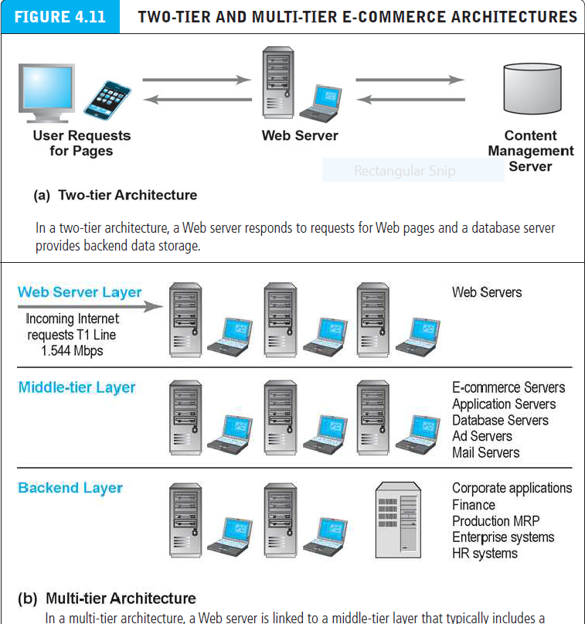

Q-4 What is good E-Commerce security ? Discuss three key points of vulnerability in e-commerce environment.
• E-commerce security is that the protection of e-commerce assets from unauthorized access, use, alteration, or destruction.
• The E-commerce surroundings 3 key points of vulnerability: Client; Server; Communications channel.
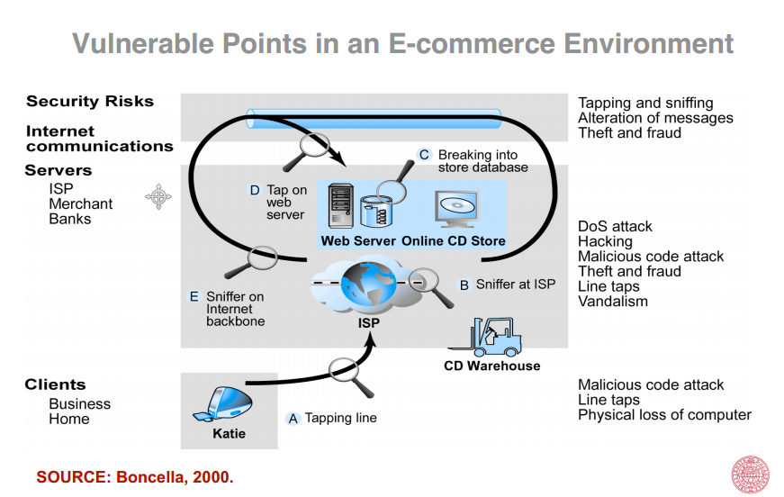
Q-5 What is the difference between hacking and cyberwar?
“Cyberwar is that the use of technology to disrupt the activities of a state or organization, particularly the deliberate assaultive of communication systems by another state or organization. not like the hacking that is a private is that the method of exploiting vulnerabilities to achieve unauthorized access to systems or resources.
A white hat hacker could be a laptop security specialist UN agency protected systems and networks when he tests and asses their security. White hat hacker use his skills up the protection by exposing vulnerabilities before malicious hackers (known as black hat hackers) will sight and exploit them.
A grey hat hacker: is someone UN agency is in between these the white and therefore the black hacker. He could use his skills for legal or ineligible acts, however not for private gains. gray hackers use their skills in
order to prove themselves that they will accomplish a determined achievement, however he ne'er lie with so as to create cash out of it. the instant they cross that boundary, they become black hackers.
Black hacker could be a one that breaks into a network or automatic data processing system with malicious intent. not like a white hat hacker, the black hat hacker takes advantage of the breaking and entering, maybe stealing information for a few future purpose or destroying files.”

References : http://www.hackersonlineclub.com/hackers-types

